Project Design Phase-II
Technology Stack (Architecture & Stack)

Date | 31 January 2025
Team ID
Project Name | AI Blog Nest API
Maximum Marks | 4 Marks
Technical Architecture:
The deliverable includes the architectural diagram below and the information in Table-1 and Table-2.
Technical architecture of AI Blog Nest API
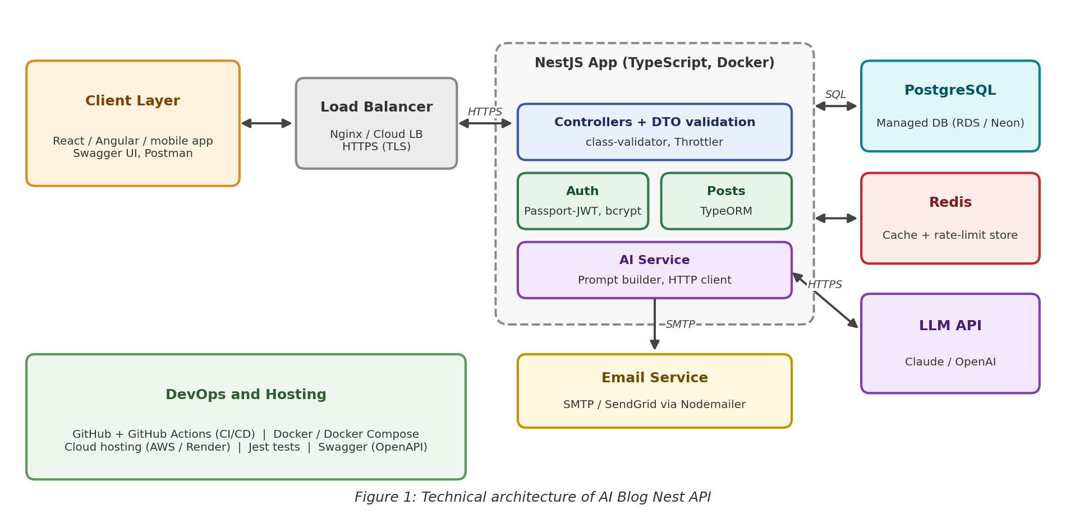
Table-1 : Components & Technologies:
S.No | Component | Description | Technology
1 | User Interface | How clients use the API: any web or mobile front-end calls the REST endpoints; developers explore and test them through interactive documentation. | React / Angular / Next.js client (consumer), Swagger UI (OpenAPI), Postman
2 | Application Logic-1 | Authentication and authorisation: registration, login, JWT access and refresh tokens, password reset, role guards. | NestJS (TypeScript), Passport-JWT, bcrypt, class-validator
3 | Application Logic-2 | Blog management: post CRUD, status workflow, categories, tags, search, pagination, version history. | NestJS modules, services and controllers, TypeORM
4 | Application Logic-3 | AI content service: builds prompts, calls the LLM, parses the response into title, body, summary and tags; rewrite, expand and shorten. | NestJS provider service, @nestjs/axios (HTTP client), prompt templates
5 | Database | Relational data: users, roles, posts, categories, tags and post versions, with indexes and migrations. | PostgreSQL, TypeORM migrations
6 | Cloud Database | Managed PostgreSQL in production, with automatic backups. | AWS RDS, Neon or Supabase
7 | Cache | Stores cached AI responses and rate-limit counters. | Redis (cache-manager, @nestjs/throttler storage)
8 | File Storage | Optional cover images for posts. Local folder in development; object storage in production. | Local filesystem (dev), AWS S3 or compatible storage (production)
9 | External API-1 | Large language model used to generate and edit blog text. | Claude API or OpenAI API (provider set by configuration)
10 | External API-2 | Sends confirmation and password-reset emails. | SMTP or SendGrid through Nodemailer
11 | Machine Learning Model | Hosted large language model used through an API for text generation and rewriting. No model is trained or hosted by the project. | Claude / GPT family models via provider API
12 | Infrastructure (Server / Cloud) | Application deployment. Local: Docker Compose runs the API, PostgreSQL and Redis. Cloud: containers behind a load balancer, built and released through a CI/CD pipeline. | Docker, Docker Compose, GitHub Actions, AWS (ECS / EC2) or Render
Table-2: Application Characteristics:
S.No | Characteristics | Description | Technology
1 | Open-Source Frameworks | Open-source frameworks and libraries used by the API. | NestJS, TypeORM, Passport, class-validator, Jest, @nestjs/swagger
2 | Security Implementations | Password hashing, token-based authentication, role-based access control, input validation, secure headers, CORS policy, rate limiting, HTTPS and secrets in environment variables, following OWASP Top 10 guidance. | bcrypt, JWT, Nest guards, Helmet, @nestjs/throttler, TLS
3 | Scalable Architecture | Modular 3-tier design (clients, NestJS application, data layer). Stateless application instances scale horizontally; the AI module can later become a separate microservice. | NestJS modules, Docker, job queue (BullMQ)
4 | Availability | Load balancer over several containers, health checks, automatic restarts, managed database with backups, and graceful handling of LLM or email failures. | Nginx / cloud load balancer, @nestjs/terminus, managed PostgreSQL
5 | Performance | Redis caching of AI responses, database indexes and pagination, response compression, and timeouts on external calls. Target: standard endpoints under 300 ms at the 95th percentile. | Redis, PostgreSQL indexes, compression middleware
References:
https://docs.nestjs.com/
https://c4model.com/
https://www.ibm.com/cloud/architecture
https://aws.amazon.com/architecture

